13.14: For SHM,
- From Eq. (13.19) the amplitude is 1.46 cm, and from Eq. (13.18) the phase angle is
0.715 rad. The angular frequency is 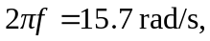so
